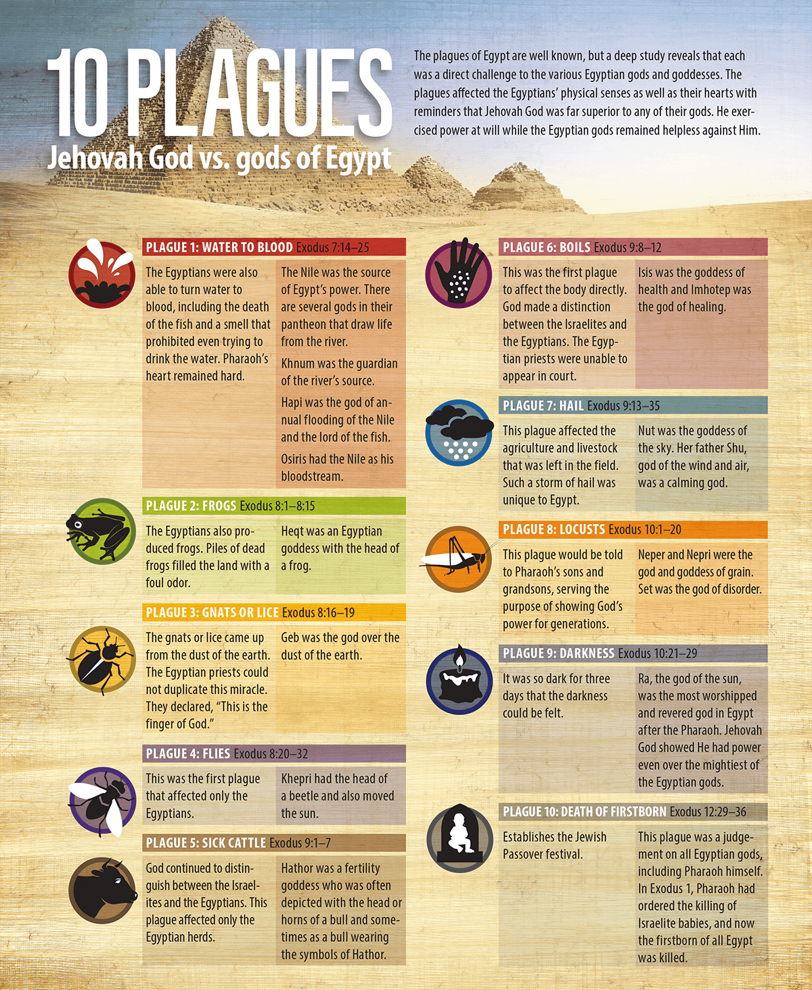

From: [Plagues of Egypt](https://housetohouse.com/wp-content/uploads/2017/03/10plagues.png)